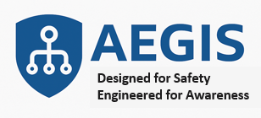
PROJECT AEGIS SOLUTION BRIEF
ADAPTIVE ERGONOMIC GEAR WITH INTELLIGENT SENSING

Theme: Smart PPE for Industrial Safety - Enhancing Monitoring, Situational Awareness, and Ergonomic Design using the CONNECT-DETECT-PROTECT (CDP) Protocol.
Table of Contents
Executive Summary 2
1. Overview 3
2. Vision and Functional Goals 4
3. Project Composition 5
4. Alignment with MxD Projects 6
5. Outcomes & Impact 6
6. Conclusion 7
APPENDIX A: PART 1 – Ergonomic Design of the Smart Folding Helmet 8
APPENDIX B: PART 2 – Smart Monitoring Data Engineering 10
APPENDIX C: AEGIS Etymological Meaning 12

Executive Summary
Numorpho Cybernetic Systems proposes a forward-looking innovation initiative that integrates industrial design, smart manufacturing, and intelligent data systems to enhance workforce safety and operational efficiency across multiple industrial domains.
Project AEGIS centers around the creation of a modular, ergonomic helmet platform that combines advanced materials, parametric 3D-printed design, and embedded sensors to support situational awareness, fatigue and motion tracking, and environmental sensing in high-risk work environments. These capabilities will be enabled by our proprietary CONNECT–DETECT–PROTECT data engineering pipeline, which facilitates real-time data acquisition, contextualization, and actionable intelligence.
Our proposed solution builds on extensive R&D efforts carried out over the past four years as active members of mHUB and MxD, including direct alignment with the strategic investment projects in Human Workflow Digital Twin, Fatigue Monitoring, and Motion Analyses led at MxD. Through collaboration with Discovery Partners Institute (DPI) and affiliated researchers at the University of Illinois Chicago (UIC), we aim to bring together industrial design and AI-based data science to co-develop a smart product ecosystem that can be scaled and integrated into the broader digital manufacturing landscape.
The Smart Folding Helmet will serve a broad set of industrial sectors - construction, oil & gas, manufacturing, mining, and defense - providing a flexible platform for both personal protective equipment (PPE) and intelligent edge computing. This project reflects a convergence of product innovation, workforce enablement, and systems-level thinking, aligned with Illinois' statewide objectives in advancing innovation, workforce resilience, and next-generation manufacturing capabilities.
By transforming research-derived knowledge into scalable smart safety systems, this initiative not only empowers frontline workers with real-time operational intelligence but also positions Illinois at the forefront of cyber-physical innovation in industry.

1. Overview
At the intersection of wearable innovation and intelligent operations, Numorpho Cybernetic Systems is developing a next-generation Smart Folding Helmet designed to transform personal protective equipment (PPE) into a dynamic, connected system for industrial safety, operational intelligence, and worker empowerment.
Our Smart Folding Helmet integrates ergonomic design, advanced sensor technology, and intelligent data engineering to serve as both a protective device and a digital interface between the worker and the operational environment.
For the past three years, we have been prototyping different variants of the helmet shell – hard hats, industrial, construction, firefighters, military, and urban variants – to have foldability and impact resistance as the key features. Our goal is to facilitate compact storage and enhance safety for users in various industries. By integrating sensors in our helmets, we are enabling not only worker safety but also operational efficiency and predictive analytics.
The primary objectives for this project are:
- Further development of ergonomic and comfortable retaining structures for our unique folding helmets, ensuring a secure and adjustable fit for users across different industries.
- Creation of a comprehensive data pipeline for managing sensor data by integrating with edge servers and IoT gateways, facilitating real-time monitoring, data analysis, and actionable insights.
- Enhancing predictive analytics capabilities through machine learning algorithms and AI-driven models, which will enable improved risk assessment, accident prevention, and overall operational efficiency.
By combining cutting-edge design, sensor technology, and data engineering, we aim to create an intelligent and adaptable Smart Folding Helmet that empowers workers and redefines industrial safety in an increasingly connected world.

2. Vision and Functional Goals
The Smart Folding Helmet will integrate ergonomic design, embedded sensors, and intelligent software into a modular PPE system that addresses modern industrial demands. Key functionalities include:
- Foldable Design – Lightweight, compact, and structurally sound for high mobility and ease of storage.
- Integrated Smart Features – Real-time monitoring via environmental, motion, and visual sensors, with wireless connectivity to edge and IoT systems.
- Ergonomics and Comfort – Designed for prolonged use, incorporating adaptive retention systems and customizable padding.
- Customizability – Modular components and accessories tailored to various roles, tasks, and environments.
- Compliance and Certification – Engineered to meet or exceed OSHA, ANSI, and PPE standards for industrial safety.
- Sustainability – Focused on eco-conscious materials and production methods to reduce environmental impact.
- Manufacturability and Scalability – Designed with mass production and supply chain efficiency in mind.
- Data Security – Incorporate NIST based cyber security protocols based on Cybersecurity Maturity Model Certification (CMMC) validated at MxD.
- Continuous Improvement – Built on a feedback-driven model to incorporate user insights and evolving technologies over time.

Safety helmets remain an indispensable, yet under-evolved, component of personal safety. This initiative aims to go beyond traditional protection, integrating intelligence and real-time connectivity into every layer of the worker’s experience - whether in a factory, a construction site, an oil & gas facility, a mining operation, or even a military frontline.
By leveraging foundational research from prior MxD SIP projects and our own intelligent protocols, Numorpho will deliver a pioneering solution that positions Illinois as a national leader in human-centered industrial innovation.

3. Project Composition
We are collaborating with several enterprises, organizations and institutes to accomplish the needs of Project AEGIS. These collaborations are focused on two critical domains of development:
- Industrial Design, for the ergonomic and structural optimization of the the helmet in conjunction with its usage in a workspace.

- AI-driven Data Engineering, to support sensor fusion, predictive analytics in conjunction with the helmet’s usage in a workspace, and the implementation of our CONNECT-DETECT-PROTECT protocol for proximity sensing, situational awareness and safety.

PART 1 – Ergonomic Design for Smart Helmet
We will engage industrial designers and engineers to create a smart helmet form factor that:
- Accommodates various helmet types via adaptable retainers and interior padding.
- Supports sensor mounting for fatigue, motion, and environmental sensing.
- Optimizes comfort, usability, and safety, enhancing adoption and compliance.
The design will be guided by human-factors engineering and will reference output from MxD's Human Workflow Digital Twin project to ensure alignment with existing workforce digitalization strategies.

PART 2 – Smart Monitoring Data Engineering
We will implement our proprietary CONNECT-DETECT-PROTECT (CDP) protocol (More Info) to manage:
- CONNECT – Real-time sensor data ingestion (environmental, biometric, motion).
- DETECT – Analysis using machine learning to identify fatigue, heat stress, hazardous movements, quality, worker collision and fall (man down).
- PROTECT – Trigger warnings when limits are exceeded, workflow recommendations, safety interventions (e.g., haptic or visual indicators) and alert first responders.
This engineering pipeline will be tailored to integrate into industrial digital twins and asset monitoring platforms.

More information about these two items is in the APPENDIX.

4. Alignment with MxD Projects
This project builds directly upon the findings and playbooks from the following MxD Strategic Investment Program (SIP) projects:
- Human Workflow Digital Twin: Fatigue and Motion Analyses
Enables predictive scheduling, real-time worker assessments, and feedback loops.
  - We will build a wearable interface that operationalizes these digital twin insights.
- Real-time Monitoring and Response Frameworks
Focused on situational awareness and predictive alerts using edge computing.
  - The CDP protocol extends this with modular data pipelines and contextual alerts for worker protection.

Together, these assets will inform both hardware form factor and the software stack, creating a high-value product extensible across domains like manufacturing, logistics, and construction.

5. Outcomes & Impact
The smart helmet will be designed to:
- Enhance personnel safety through fatigue and environment monitoring.
- Improve situational awareness in dynamic operational zones.
- Enable real-time decision-making and functional efficiency.
- Serve as a model for future industrial wearables integrated into digital twin ecosystems.

Expected deliverables:
- Ergonomically validated helmet prototype with modular smart components.
- Software stack implementing the Smart Monitoring CONNECT-DETECT-PROTECT protocol for integration with edge/cloud platforms.
- Integration documentation for deployment in MxD-aligned or partner environments.

6. Conclusion
This initiative represents a timely and transformative opportunity to bridge the gap between cutting-edge research in digital twins, human performance monitoring, and applied industrial safety. By extending the work done by us in pioneering Additive Manufacturing, Materials Research and Electronic Componentry and translating foundational work done through MxD SIP projects and the CONNECT-DETECT-PROTECT protocol into a deployable smart product, Numorpho Cybernetic Systems will operationalize innovation into real-world impact.

Through the strategic integration of ergonomic industrial design, intelligent sensor fusion, and scalable data engineering, the Smart Folding Helmet will emerge as a next-generation PPE platform—offering not just protection, but real-time situational intelligence, adaptability to dynamic work environments, and enhanced worker well-being.

Aligned with the Illinois Science and Technology Coalition’s mission, this project supports:
- Innovation in smart manufacturing through the development of cyber-physical systems with practical applications.
- Workforce resilience by enhancing occupational health and safety through fatigue monitoring, motion analysis, and hazard detection.
- Leadership in advanced manufacturing by fostering collaboration between startups, research institutions, and design professionals across Illinois.

With a clear path to manufacturability and a strong foundation in research and systems engineering, this endeavor exemplifies how Illinois-based companies can lead in shaping the future of human-centered industrial technologies.

APPENDIX A: PART 1 – Ergonomic Design of the Smart Folding Helmet
Here is a diagram showcasing the different folding types we investigated as part of defining the design pattern to utilize for the mechanism.
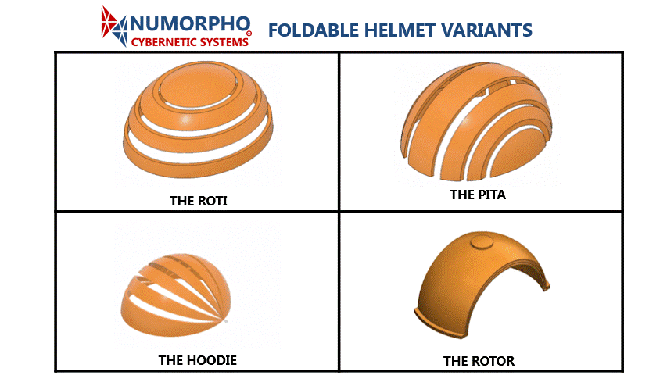
This component focuses on the physical and functional design of the Smart Folding Helmet with emphasis on the retention and padding system to enable integrating safety, comfort, modularity, and manufacturability into one cohesive platform.
In collaboration with industrial designers from the University of Illinois at Chicago (UIC), we aim to develop a helmet that can fold for easy portability while retaining structural integrity and meeting industrial safety standards.
Key Deliverables:
- Folding Mechanism Design: Engineering a collapsible helmet structure using lightweight, impact-resistant materials that maintain compliance with PPE certifications (ANSI/ISEA Z89.1, EN 397, etc.). The folding design has already been created, but the certifications are pending and will also be based on the retention system we design in this project.
- Retention and Padding Systems: Development of internal components such as adjustable harnesses, moisture-wicking padding, and energy-dispersing liners tailored to various use cases (e.g., construction, heavy manufacturing, military).
- Ergonomic Assessment: Iterative prototyping and testing using human factors analysis and motion capture tools (building on prior work from the MxD SIP project on fatigue and motion analysis).
- Customization Framework: A modular accessory interface for attaching lighting, communication units, AR visors, and other edge-enabled tools.
- Sustainability Review: Selection of sustainable materials and supply chain-friendly components to minimize environmental impact and facilitate scalable production.
This phase is essential to ensuring the Smart Helmet can be worn comfortably for extended periods and adapted across environments without sacrificing worker safety or operational efficiency.

APPENDIX B: PART 2 – Smart Monitoring Data Engineering
Here is our Use Case for Smart Monitoring that utilizes our sensor embedded helmets to achieve motion and environmental monitoring in industrial settings.
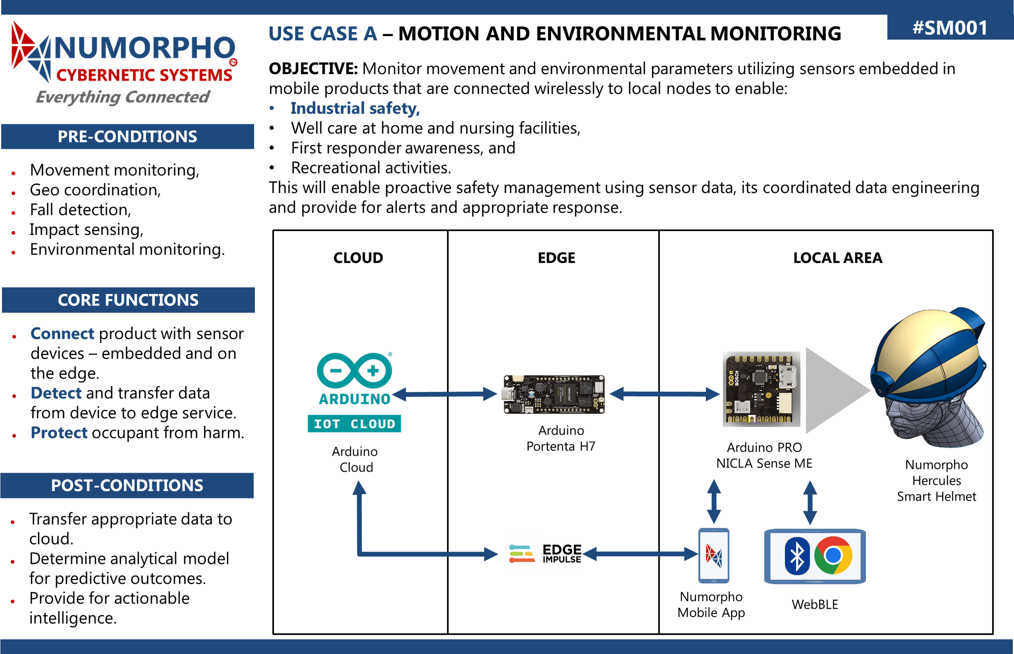
This component will bring intelligence and situational awareness into the helmet system by integrating sensor fusion, edge connectivity, and data analytics.
We will operationalize our proprietary CONNECT-DETECT-PROTECT protocol (https://numorpho.org/2023/04/22/connect-detect-protect/) to create a dynamic feedback loop between the worker, the environment, and the operational system.
Key Capabilities:
- Sensor Suite Integration: Onboard environmental sensors (e.g., temperature, gas, sound), motion sensors (accelerometers, gyroscopes), and vision-based modules (for hazard detection and fatigue monitoring).
- Edge Gateway Connectivity: Real-time wireless communication between helmet units and edge/cloud systems via IoT gateways for data aggregation, local processing, and latency reduction.
- Predictive Analytics: Development of machine learning pipelines that analyze trends in worker fatigue, posture deviation, environmental hazards, and proximity alerts to generate actionable alerts and performance insights.
- Digital Twin Interfacing: Compatibility with human workflow digital twins as developed in MxD SIP projects to provide synchronized performance data and inform operational adjustments in real time.
- Data Security & Compliance: Implementation of secure transmission protocols, anonymized data handling, and compliance with data privacy standards (GDPR, HIPAA, CCPA where applicable).
The data infrastructure will not only ensure worker safety but will also enable organizations to assess workforce readiness, manage risks proactively, and optimize operational workflows at scale.

APPENDIX C: AEGIS Etymological Meaning
In ancient mythology, the Aegis was the divine shield wielded by Zeus and Athena, symbolizing protection, authority, and foresight. It was more than armor—it was a sacred emblem of vigilance, power, and strategic defense.
From Wiki:
The aegis (/ˈiːdʒɪs/ EE-jis;^{[1]} Ancient Greek: αἰγίς aigís), as stated in the Iliad, is a device carried by Athena and Zeus, variously interpreted as an animal skin or a shield and sometimes featuring the head of a Gorgon. There may be a connection with a deity named Aex, a daughter of Helios and a nurse of Zeus or alternatively a mistress of Zeus (Hyginus, Astronomica 2. 13).^{[2]}
The modern concept of doing something "under someone's aegis" means doing something under the protection of a powerful, knowledgeable, or benevolent source. The word aegis is identified with protection by a strong force with its roots in Greek mythology and adopted by the Romans; there are parallels in Norse mythology and in Egyptian mythology as well, where the Greek word aegis is applied by extension.
At Numorpho Cybernetic Systems, we embrace this symbolic legacy in naming our project AEGIS for Adaptive Ergonomic Gear with Intelligent Sensing.
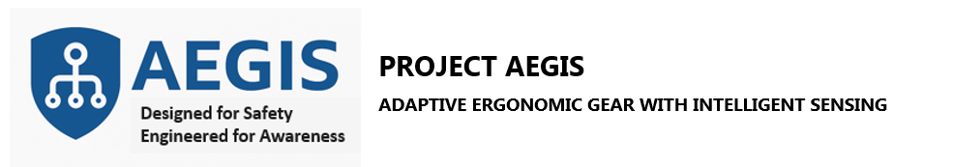
AEGIS reflects our mission to protect frontline workers not just physically, but cognitively and operationally—through wearable intelligence, real-time situational awareness, and predictive insights. The helmet is not just a shield—it is a sentinel, engineered to monitor, interpret, and act in service of human safety.
The meaning of AEGIS for us encapsulates:
- Protection — Physical safety through ergonomic structure and compliance with PPE standards.
- Awareness — Intelligent sensing and real-time data interpretation through the CONNECT-DETECT-PROTECT protocol.
- Empowerment — Giving workers and their environments the ability to proactively address fatigue, hazards, and inefficiencies.
- Trust and Leadership — Designed as a dependable companion in industrial operations, symbolizing strength, foresight, and technological guardianship.
Thus, in both name and function, AEGIS is “Designed for Safety, Engineered for Awareness”—honoring its mythological roots while redefining what protective gear means in the age of Industry and Services 5.0.
Commercially, this project opens up product pathways in industrial wearables, defense logistics, construction monitoring, and enterprise safety solutions. It sets the stage for future product lines involving mobile vision systems, AR overlays, biofeedback devices, and networked PPE for distributed workforces. It would also provide a basis for digital twinning industrial and infrastructure operations to enable safety, operational efficiency and predictive analytics to facilitate proactive decision-making and optimized resource allocation. By integrating real-time data from connected wearable devices and intelligent sensors, organizations can enhance their situational awareness and make informed choices to improve overall safety, efficiency, and productivity.
The implementation of these technologies would also pave the way for the development of advanced simulation and training systems. By leveraging digital twin technology, businesses can create immersive virtual environments to train workers in various scenarios, helping them to develop critical skills in a safe, controlled setting.
Furthermore, the insights gained from this project could contribute to the advancement of preventative maintenance strategies. By monitoring equipment and worker performance, potential issues can be identified and addressed before they escalate, reducing downtime and maintenance costs.
In summary, the commercial potential of this project is vast, with applications spanning multiple industries and use cases. It not only addresses immediate safety and efficiency concerns but also sets the foundation for future innovations in wearable technology, biofeedback devices, and networked PPE solutions. It empowers organizations to optimize their operations and make data-driven decisions that drive growth and success.

