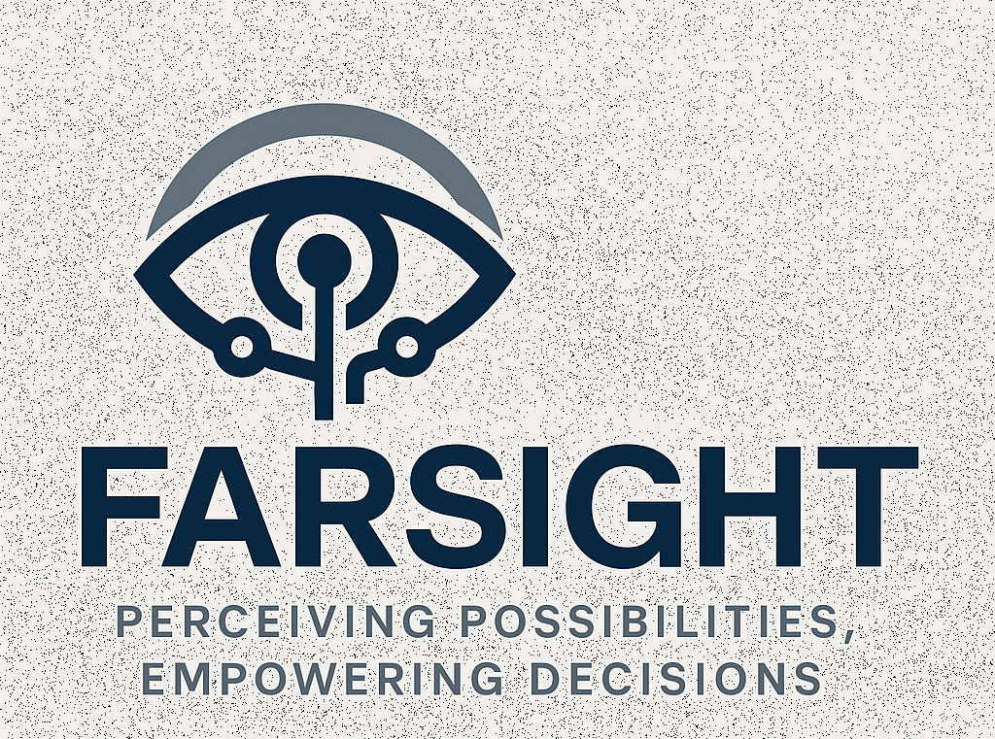
Fusion-driven Analytics and Responsive Situational Intelligence for Tactical Efficiency

Project Name | FARSIGHT
DIU Solicitation | PROJ00592 - SAILS (Situational Awareness by Intelligent Learning Systems)
Submitted by | Numorpho Cybernetic Systems  1623 W Fulton St  Chicago, IL 60612
Contact | Nitin Uchil, Founder & CEO  Phone: 1-734-945-6463  Email: nitin.uchil@numorpho.com
Date Created | 6/6/2025

Theme: Trained for Insights, Tuned for Action – Expand Smart Monitoring to enable multi-source data fusion and situational awareness using Numorpho’s CONNECT-DETECT-PROTECT (CDP) Protocol.
Table of Contents
Executive Summary 2
Technology Concept 3
Use Case Scenarios 4
Company Viability 5
Appendix A: AEGIS Use Cases 7

We will be partnering with Dr. Alvin Chin from Discovery Partners Institute (DPI) and utilizing the subject matter expertise of MxD in the progression of this project.

Executive Summary
Initiative SAILS (Situational Awareness by Intelligent Learning Systems) seeks next-generation, cybernetically orchestrated platform for adaptive, resilient, and ethical process engineering, tailored to the Defense Innovation Unit’s mission requirements for the Navy. Our response built on Numorpho’s process engineering MANTRA M5 framework is our project codenamed FARSIGHT (Fusion-driven Analytics and Responsive Situational Intelligence for Tactical Efficiency). Here we will integrate digital twins, multimodal AI, blockchain-secured workflows, and agentic architectures to deliver real-time situational awareness, rapid decision support, and continuous mission optimization. This approach synthesizes the latest advances detailed in our “Everything Connected” articles, ensuring that defense operations are agile, explainable, and future-proof.
Building upon the strong foundation of Project AEGIS (see Use Cases in Appendix A), which delivers real-time safety, environmental monitoring, and predictive analytics via the CONNECT–DETECT–PROTECT (CDP) protocol, this project proposes to expand the capabilities of its Smart PPE platform to align with the U.S. Navy’s need for enhanced multi-source data fusion and situational awareness under the SAILS initiative. Through modular and adaptive AI/ML frameworks integrated within ergonomic, sensor-embedded helmets, we aim to deliver a dual-use capability that addresses the complexities of defense watchfloor operations, enabling predictive decision support, track confidence scoring, and intelligent asset/resource optimization for distributed maritime and joint operations. Our Digital Twine World Model (DTM) seamlessly connects people, processes, and technology to provide real-time situational understanding and informed decision-making. This innovative architecture supports future-proofing mechanisms and fosters resilience in industrial settings.
Numorpho Cybernetic Systems will be the lead for this project, and we will be collaborating with MxD, the premier DoD funded organization that institutes playbooks for advanced manufacturing, cybersecurity and supply chain logistics that we are members of, and DPI (Discovery Partners Institute) that is part of the University of Illinois System with Dr. Alvin Chin leading the data engineering and artificial intelligence. This will be instrumental in ensuring the successful development and deployment of FARSIGHT.

Technology Concept
While Project AEGIS (Adaptive Ergonomic Gear with Intelligent Sensing) focused on smart monitoring to enable worker safety in industrial environments, its architecture is inherently extensible to extend to situational awareness for the SAILS initiative. Our modular CDP pipeline, digital twin integration, and edge-compatible design allow seamless adaptation to defense environments where real-time decision-making under data overload is a critical need.
Project FARSIGHT introduces enhancements to:
- Integrate structured and unstructured data from shipboard, airborne, and satellite platforms.
- Provide real-time recommendations, asset scoring, and track confidence for Maritime Operations Centers (MOCs).
- Extend safety and data engineered PPE systems to double as command-integrated wearable terminals.

Modern defense environments are defined by volatility, uncertainty, and the need for rapid, data-driven adaptation. Legacy systems are siloed, slow to respond, and lack the feedback-rich intelligence necessary for today’s multi-domain operations. Project FARSIGHT addresses these gaps by:
- Fusing real-time sensor, logistics, and operational data into actionable digital twins based on the extension of the smart monitoring platform developed in Project AEGIS.
- Enabling distributed, swarm-based AI for collective intelligence and rapid response.
- Embedding ethical guardrails and explainability into every workflow, in line with the constitutional and manifesto-based frameworks developed by Numorpho to explicitly articulate the principles, should conditions and do’s and don’ts of the platform.

Functional Extension Goals for FARSIGHT
1. Watchfloor Workflow Automation
- API-based integration with Navy systems using RESTful, secure endpoints.
- Smart forms and mission-specific automation to route data and flag discrepancies.
- Sensor-embedded voice or gesture interfaces for hands-free interaction with workflow systems.
2. Track Confidence Determination
- On-device ML modules to assess sensor trust, asset readiness, and operational accuracy.
- Tunable scoring mechanisms based on evolving mission priorities, geolocation, and system health.
3. Sensor and Resource Optimization Based on Proximity Monitoring
- Integrated AI agents use proximity monitoring to enable connectivity with relevant edge devices that model resource tradeoffs: e.g., deploy which UAVs based on bandwidth, weather, or watchstander fatigue. This work will be performed by Dr. Alvin Chin from DPI.
- Modular optimization routines supporting rapid what-if analysis and commander-driven feasibility tuning.
4. Trust with the Warfighter; Modularity for the Force
- Natural language tuners to allow end-users to update mission constraints dynamically.
- Fully decoupled architecture: UX/UI ↔ Data Ingest ↔ Logic Core.
- Helmet-based voice interface supports "explainability on demand" for model decisions.
- Continuous training modules and embedded simulation interfaces for onboarding and trust-building.

Use Case Scenarios
Herewith are the different use cases that will form the basis for Project FARSIGHT by extending the smart monitoring features of project AEGIS to include multi-source data fusion and situational awareness. We will follow Technical Readiness Level (TRL) starting from Level 4 up to 9 to progress the maturing of the solution.
Domain | Use Case | Basis from Project AEGIS  (See Use Cases in Appendix A)
Fleet Operations | Resource recommendation for satellite/aircraft deployment based on real-time confidence scoring. | Optimizing and harmonizing operations on the shop floor
Disaster Response | Mobile coordination of first responders using contextual alerts and environmental telemetry. | CONNECT-DETECT-PROTECT to enable worker safety, operational efficiency and predictive analysis and provide proactive dashboards to enable simulation, troubleshooting and workforce enablement
Coastal Reconnaissance | Edge-processed sensor fusion combining motion, visual, and acoustic cues to detect intrusions.
Watchfloor Management | Automatic alert generation from unstructured watch logs or anomaly-detection in heatmaps.
Training & Simulation | Real-time digital twin feedback loop enables immersive mission rehearsal and post-op debrief with performance analytics. | AR/VR based training and real-time support to technicians on the shop floor

Company Viability
Numorpho Cybernetic Systems (NUMO) is a Chicago-based startup specializing in the development of smart, connected, and sustainable products that integrate advanced technologies across physical, digital, and biological domains. Founded in 2021 by Nitin Uchil, NUMO focuses on process automation, intelligent product development, and adaptive engineering to facilitate businesses’ transition into Industry 4.0 and beyond. Details of our purpose, current fund raising and go-to-market are in our one-page FactSheet.
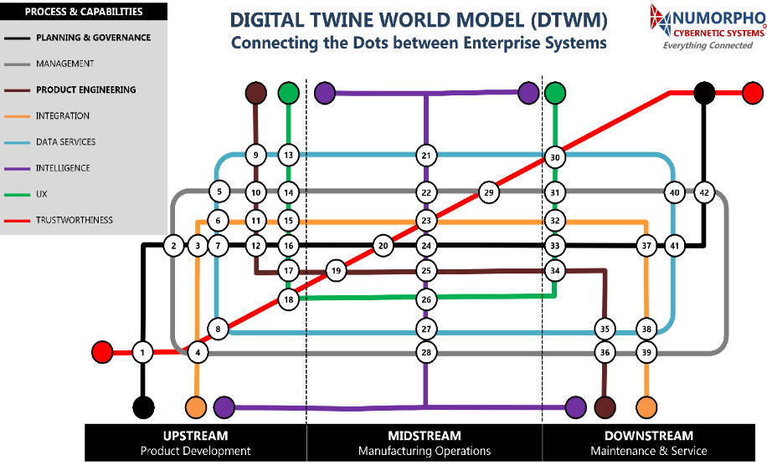
Numorpho's Digital Twine World Model (DTWM) is a groundbreaking reference architecture that enables intelligent agentic interactions and automation across diverse systems, data sources, and processes. It is an aggregation of digital twins and digital threads that merge at “connected dots” that represent people, processes and technologies coming together to define the business needs and technical requirements of the intersecting streams.
Utilizing our Digital Twine World Model (DTWM) reference architecture, we have embarked on creating several digital twins that encompass end-to-end process management to enable connecting the dots for automation in Industry 4.0 initiatives:
- The Operational Digital Twine (ODT) enables localized production of parts in military frontline operations.
- The Interoperable Digital Twine Framework (IDTF) enables the coupling of engineering and manufacturing to create spare parts.
- The Connected Factory Digital Twine (CFDT) connects the physical and digital worlds in a manufacturing environment to create a virtual representation.
- The Future Factory Digital Twine (FFDT) provides guidance for architecting digital twins that follow standards, industry best practices.
- The Smart City Connect Framework (SCCF) is a project that will create a cyber-physical visual rendering of the City of Chicago using Virtual and Augmented reality to superpose information onto a physical 3D architectural rendering.
- The Smart Monitoring Digital Twine (SMDT – basis for project AEGIS) is the formulation of the Connect-Detect-Protect protocol.
We have also created a smart and connected helmet that is being marketed as Personnel Protection Equipment (PPE) in the manufacturing, construction, firefighter and military domains that is additively manufactured and uses embedded sensors and advanced materials. For our go-to-market strategy, we are working with our partners on a staged marketing roll-out to enable a graded progression in commercialization starting with B2B/Distributor basis and later moving to B2C selling for our Bicycle and Urban wear helmets.
The collaboration with DPI, as part of the University of Illinois System, and with Dr. Alvin Chin, further bolsters our access to a wealth of knowledge and resources in research and innovation. This partnership will enable us to tap into a diverse talent pool, ensuring that FARSIGHT benefits from interdisciplinary insights and expertise.
MxD's expertise in advanced manufacturing, cybersecurity, and supply chain logistics will provide the necessary guidance to build resilient and secure systems tailored to the unique requirements of defense operations. Moreover, by leveraging MxD's established playbooks, we can implement proven strategies and best practices for developing cutting-edge solutions that are adaptable, efficient, and secure.

Appendix A: AEGIS Use Cases
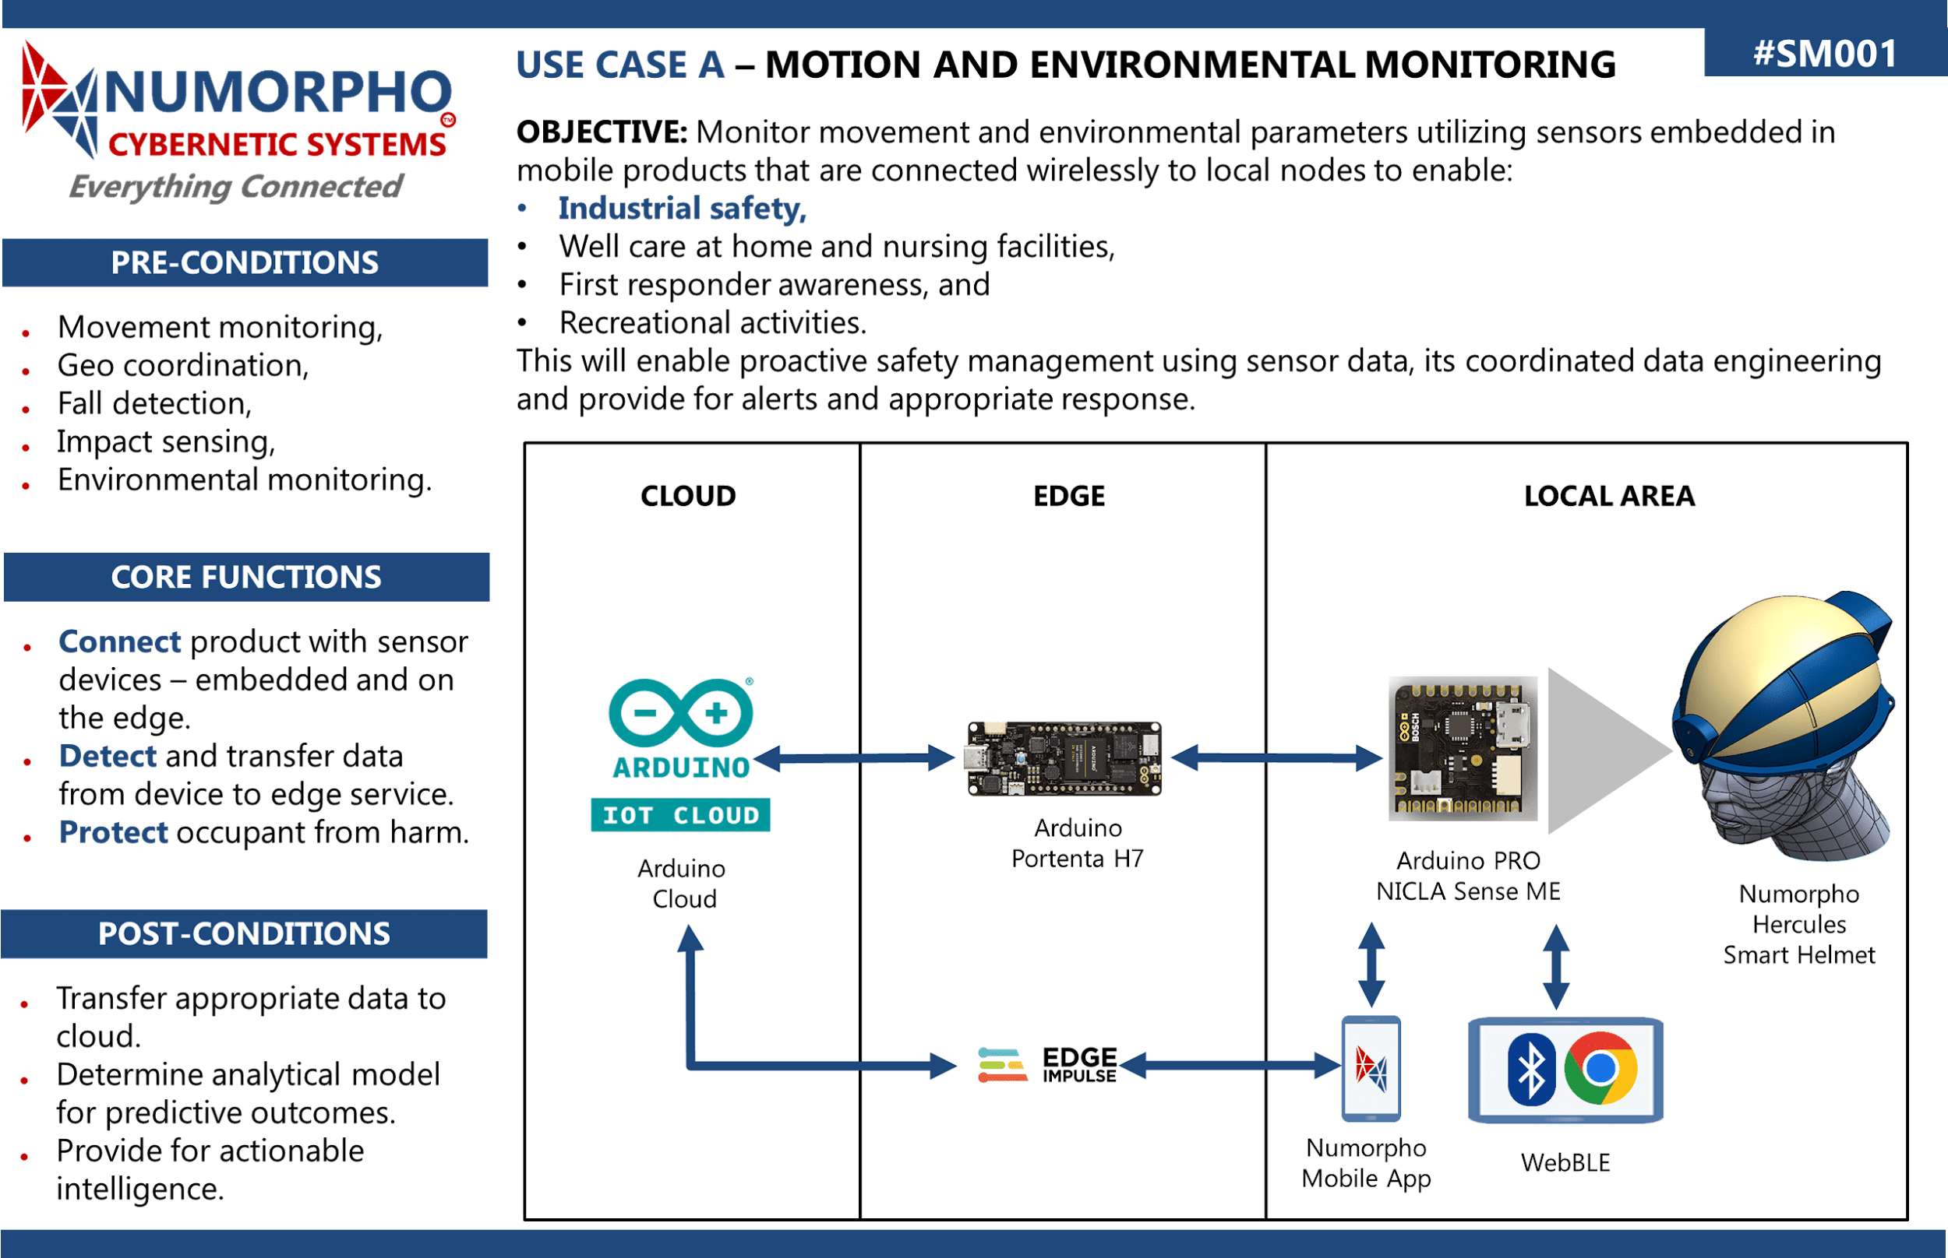
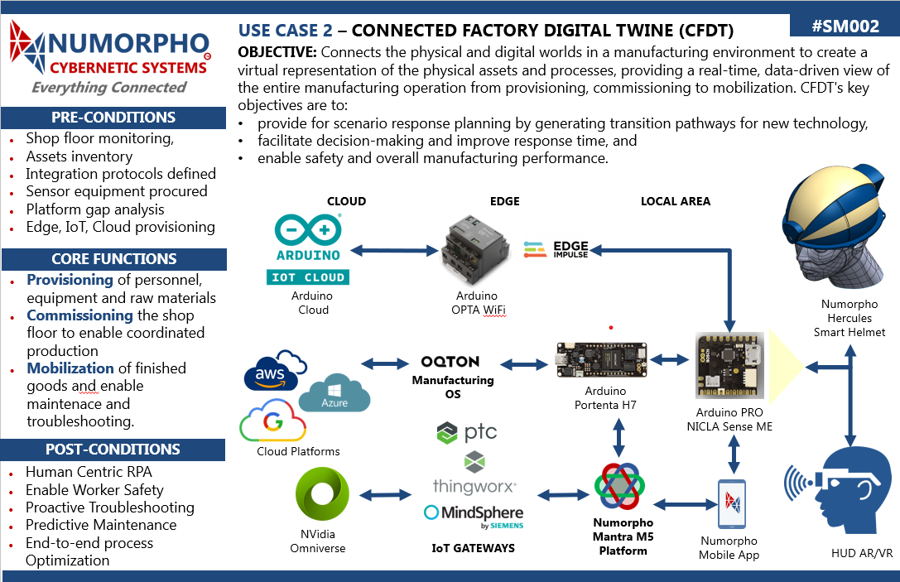

REFERENCES
- https://www.persistentsystems.com/persistent-systems-company/ for Situational Awareness

